**PROJECT REPORT**

**ON**

**ARDUINO PROJECT**

**MECHATRONICS(MEPC-309)**

**SUBMITTED BY:- SUBMITTED TO:-**

INAYAT KAMBOJ(20109048) DR. JOSEPH ANAND VAZ

MANSHUL GOYAL(20109056)

**INTRODUCTION TO ARDUINO UNO R3**

**Arduino UNO specifications:**

• Operating Voltage = 5V

• Input Voltage (recommended) = 7-12V

• Digital I/O Pins = 14 (of which 6 provide PWM output)

• PWM Digital I/O Pins = 6

• Analog Input Pins = 6

Arduino is an open-source electronics platform based on easy-to-use hardware and software. You can tell your board what to do by sending a set of instructions to the microcontroller on the board using an IDE (integrated development environment). Arduino UNO R3 uses a ATmega 328P Microcontroller.

ATmega328P Specifications

• Flash memory: 32KB

• SRAM: 2KB • EEPROM: 1KB

• Maximum CPU speed: 20MHz

Flash memory: A kind of memory that retains data in the absence of a power supply.

SRAM: Volatile memory. Data is lost when power goes off.

EEPROM: a read-only memory whose contents can be erased and reprogrammed.

Image of Arduino Uno

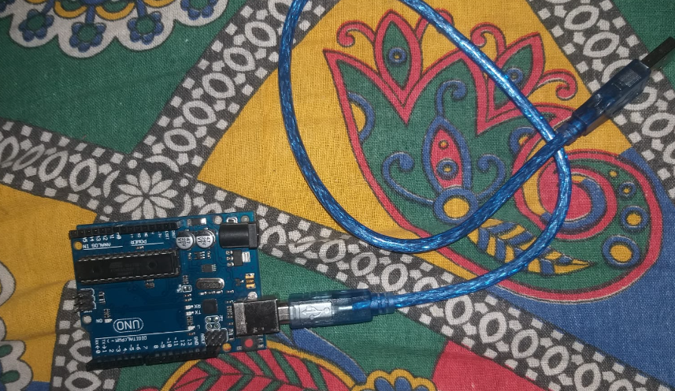

WHAT DO U MEAN BY PWM?

PWM is a stream of voltage pulses that reduces the electric power supplied by electrical signal. PWM is describing a type of digital signal.It is the way to control analog devices with digital output

DIAGRAM

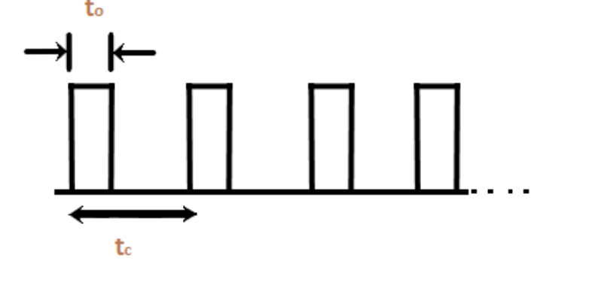

DUTY CYCLE = t0/t

t0= signal high(duration of signal)

t= low signal (total duration of signal)

**ARDUINO COMMANDS**

* digitalRead()

Value will be read from a specified digital pin.

digitalRead( pin)

type the arduino pin number which we want

return: high or low;

*digitalWrite()

Syntax:

digitalWrite(pin, value)

Parameters:

pin: the Arduino pin number.

value: HIGH or LOW.

* pinMode()

Syntax:

pinMode(pin, mode)

Parameters:

pin: the Arduino pin number to set the mode of.

mode: INPUT, OUTPUT, or INPUT_PULLUP.

**\*** analogRead()

Syntax:

analogRead(pin)

Parameters:

pin: the name of the analog input pin to read from (A0 to A5 on most boards, A0 to

A6 on MKR boards, A0 to A7 on the Mini and Nano, A0 to A15 on the Mega).

**\*** analogWrite()

Syntax:

analogWrite(pin, value)

Parameters:

pin: the Arduino pin to write to. Allowed data types: int.

value: the duty cycle: between 0 (always off) and 255 (always on). Allowed data

types: int.

* delay()

Syntax:

delay(ms)

Parameters:

ms: the number of milliseconds to pause. Allowed data types: unsigned long.

* sin()

Syntax:

sin(rad)

Parameters:

rad: The angle in radians. Allowed data types: float

**COMPONENTS USED AND THEIR IMPLEMENTATION**

1.JUMPER WIRE

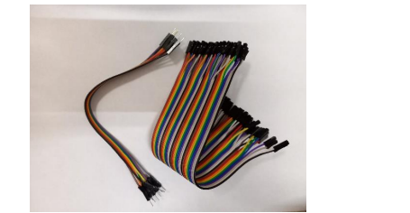

2. ARDUINO UNO

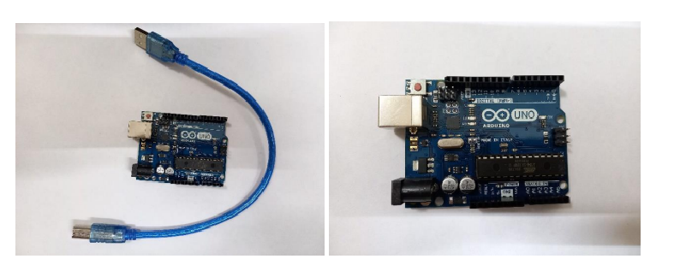

3.BREADBOARD

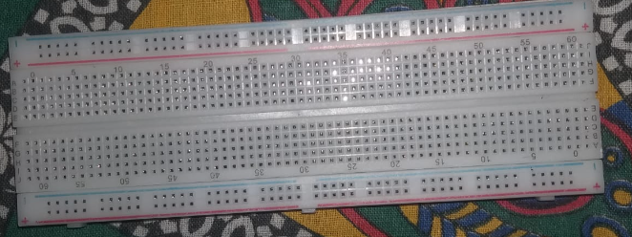

5.OSCILLOSCOPE

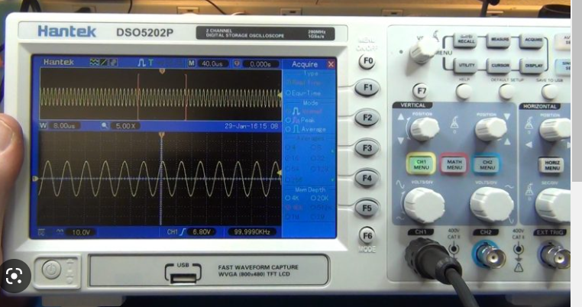

6.RESISTORS

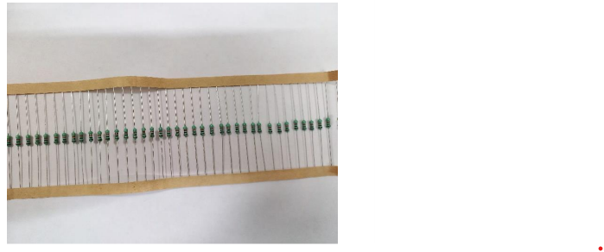

**ARDUINO SETUP**

*SINE WAVE

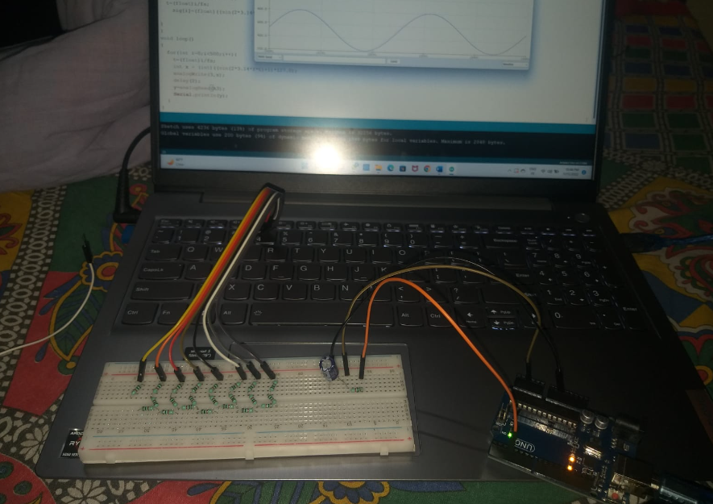

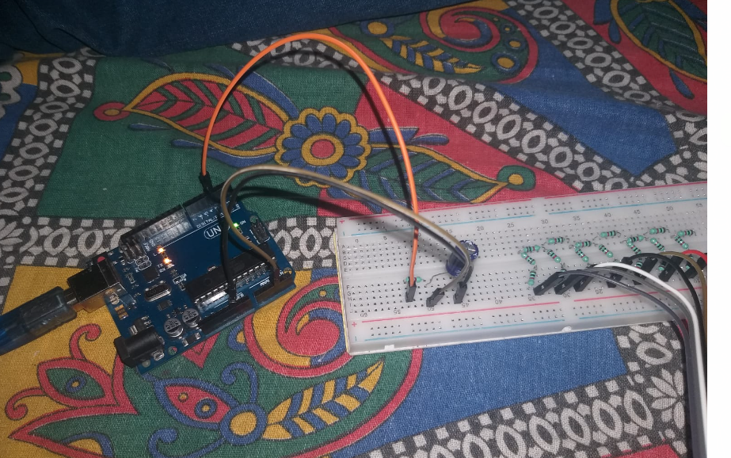

* SQUARE WAVE

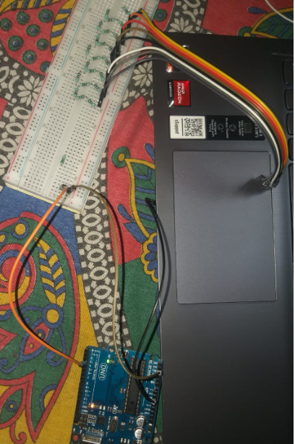

* TRIANGULAR WAVE

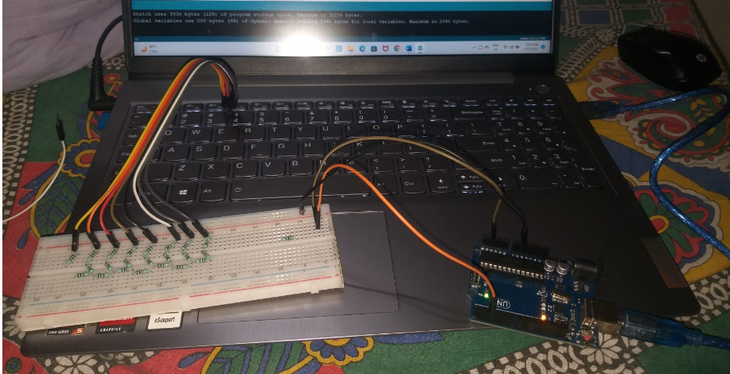

GENERATION OF SINE WAVE

**CODE**

int f=2;

float fs=500;

int sig[500];

float y;

float t;

void setup()

{

Serial.begin(9600);

pinMode(3,OUTPUT);

for(int i=0;i<500;i++){

t=(float)i/fs;

sig[i]=(float)((sin(2*3.14*f*t)+1)*127.0);

}

}

void loop()

{

for(int i=0;i<500;i++){

t=(float)i/fs;

int x = (int)((sin(2*3.14*f*t)+1)*127.0);

analogWrite(3,x);

delay(2);

y=analogRead(A3);

Serial.println(y);

}

}

**DIAGRAM**

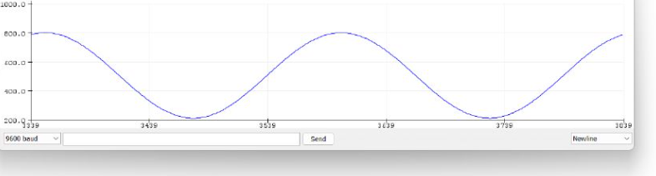

GENERATION OF SQUARE WAVE

**CODE**

void setup()

{

//pinMode(LED_BUILTIN, OUTPUT);

Serial.begin(9600);

pinMode(3,OUTPUT);

pinMode(A3,INPUT);

}

void loop()

{

float y;

/*digitalWrite(LED_BUILTIN, HIGH);

delay(1000); // Wait for 1000 millisecond(s)

digitalWrite(LED_BUILTIN, LOW);

delay(1000); // Wait for 1000 millisecond(s)*/

for(int i=0;i<10;i++){

analogWrite(3,255);

delay(100);

y=analogRead(A3);

Serial.println(y);}

for(int i=0;i<10;i++){

analogWrite(3,0);

delay(100);

y=analogRead(A3);

Serial.println(y);

}

}

**DIAGRAM**

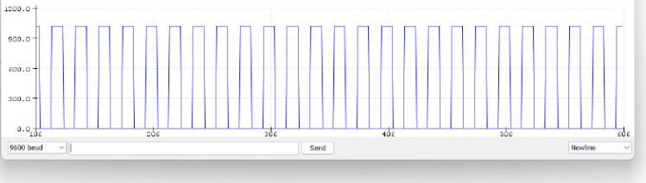

GENERATION OF TRIANGULAR WAVE

**CODE**

float y ;

void setup(){

pinMode(3, OUTPUT);

pinMode(A3, INPUT);

Serial.begin(9600);

}

void loop(){

for(int i=0; i<10; i++){

if(i<5){

analogWrite(3, 50*i);

y = analogRead(A3);

Serial.println(y);

delay(10);

}

else {

analogWrite(3L, 50*(10-i));

y = analogRead(A3);

Serial.println(y);

delay(10);

}

}

}

**DIAGRAM**

